Software Requirement Specification  
(SRS DOCUMENT)

for

**Shopping System**

Version 1.0

**Submitted By:**

**Mad Cabbage**

**Gun**

**Student**

**Mathematikos**

**Table of Contents**

1. Introduction 1

**1.1** **Purpose** 1

**1.2** **Scope** 1

**1.3** **Modules** 1

2. Overall Description 2

**2.1** **User classes and characteristics** 2

**2.2** **Operating Environment** 2

3. Requirement Identifying Technique 2

**3.1.** **User Requirements:** 2

**3.2.** **Use Case(s) Diagram:** 3

4. Functional Requirements 4

**4.1.** **Use Case(s) (List):** 4

# 

# Introduction

## **Purpose**

Purpose of shopping system is to provide the customers with a efficient system to shop the items they require with ease and face no problems while doing so. Shopping system introduces basic UI use to ensure easy and seamless online shopping experience.

## **Scope**

• Online Shopping system

• Admin Profiling

• Customer Profiling

• User data editing

• User data encryption

• Adding Shopping items in the system

• Adding users in the system

• Adding shopping items in user cart

• UI design

## **Modules**

1. **Admin Profiling:**

UC-1.1 Admin Login/Sign Up

UC-1.2 Admin Password/Username

UC-1.3 Change Password/Username

UC-1.4 Add Customer

UC-1.5 Edit Customer Data

UC-1.6 Edit Items Data

1. **Customer Profiling**

UC 2.1 Customer Login/Sign Up

UC 2.2 Admin Password/Username

UC 2.3 Change Password/Username

1. **Shopping Item:**

UC 3.1 Add Item

UC 3.2 Manipulate Item data

UC 3.3 Delete Items

UC 3.4 Item out of stock, item out of order

1. **Shopping Cart:**

UC 4.1 Check out

UC 4.2 Delete items from cart

UC 4.3 Payment Methods

1. **UI Design:**

UC 5.1 Login/Sign-up UI

UC 5.2 Shopping List UI

UC 5.3 Shopping Cart UI

UC 5.4 Checkout UI

1. **Data Management:**

UC 6.1 Item Data

UC 6.2 Customers Data

UC 6.3 Shopping List Data

UC 6.4 Shopping List Customers Data

UC 6.5 Login Data

UC 6.6 Database Encryption

# Overall Description

## **User classes and characteristics**

Possible User Classes:

1. Shop
2. Shopping Sections
3. Shopping Cart
4. Item
5. User
6. Admin
7. Customer
8. UI Elements
9. Data Storage Elements
10. Exception Handling Elements

## **Operating Environment**

* Console
* Windows
* Java JDK Ver 17

# Requirement Identifying Technique

## **User Requirements:**

**As a user...**

I want to sign up for an account to access the shopping cart functionality.

I want to log in to my account to view my shopping cart and previous orders.

I want to search for products by name, category, or price range.

I want to view detailed information about a product before adding it to my cart.

I want to add products to my cart by specifying the quantity I wish to purchase.

I want to remove products from my cart if I change my mind or no longer want them.

I want to view the total price of all items in my cart before proceeding to checkout.

I want to update the quantity of items in my cart if I decide to change the quantity before checkout.

I want to apply discounts or promotional codes to my cart to receive discounts on my purchase.

I want to view shipping options and costs before finalizing my order.

I want to enter shipping and billing information for delivery of my order.

I want to review my order summary before confirming and paying for my purchase.

I want to receive a confirmation email with order details after completing my purchase.

I want to view my order history and track the status of my orders.

**As an admin...**

I want to manage user accounts, including creating, updating, and deleting accounts.

I want to add new products to the store by providing details such as name, description, price, and quantity available.

I want to edit existing product details such as name, description, price, and quantity available.

I want to remove products from the store that are no longer available or have been discontinued.

I want to view a list of all orders placed by users, including order details and status.

I want to update the status of orders, such as marking them as shipped or canceled.

I want to generate reports on sales, revenue, and inventory levels to monitor store performance.

I want to manage categories and organize products into different categories for easier navigation.

I want to set up and manage discounts, promotions, and special offers for products.

I want to communicate with customers via email or messaging to provide updates on orders or promotions.

I want to manage the content and layout of the store's homepage and other pages to keep them up-to-date and engaging.

I want to configure and manage payment and shipping options for customers to choose from during checkout.

I want to monitor and analyze website traffic and user behavior to optimize the shopping experience.

I want to handle customer inquiries, feedback, and complaints promptly and effectively.

## **Use Case(s) Diagram:**

**Actors:**

1. Admin
2. Customer
3. System

# Functional Requirements

## **Use Case(s) (List):**

**Module 1: Admin Profiling:**

|  |  |
| --- | --- |
| **M1-UC1** | Admin Login/Sign Up |
| **M1-UC2** | Admin Password/Username |
| **M1-UC3** | Change Password/Username |
| **M1-UC4** | Add Customer |
| **M1-UC5** | Edit Customer Data |
| **M1-UC6** | Edit Items Data |

**Module 2: Customer Profiling**

|  |  |
| --- | --- |
| **M2-UC1** | Customer Login/Sign Up |
| **M2-UC2** | Admin Password/Username |
| **M2-UC3** | Change Password/Username |

**Module 3: Shopping Item:**

|  |  |
| --- | --- |
| **M3-UC1** | Add Item |
| **M3-UC2** | Manipulate Item data |
| **M3-UC3** | Delete Items |
| **M3-UC4** | Item out of stock, item out of order |

**Module 4: Shopping Cart:**

|  |  |
| --- | --- |
| **M4-UC1** | Check out |
| **M4-UC2** | Delete items from cart |
| **M4-UC3** | Payment Methods |

**Module 5: UI Design:**

|  |  |
| --- | --- |
| **M5-UC1** | Login/Sign-up UI |
| **M5-UC2** | Shopping List UI |
| **M5-UC3** | Shopping Cart UI |
| **M5-UC4** | Checkout UI |

**Module 6: Data Management:**

|  |  |
| --- | --- |
| **M6-UC1** | Item Data |
| **M6-UC2** | Customers Data |
| **M6-UC3** | Shopping List Data |
| **M6-UC4** | Shopping List Customers Data |
| **M6-UC5** | Login Data |
| **M6-UC6** | Database Encryption |

*.*

**Context Diagram**

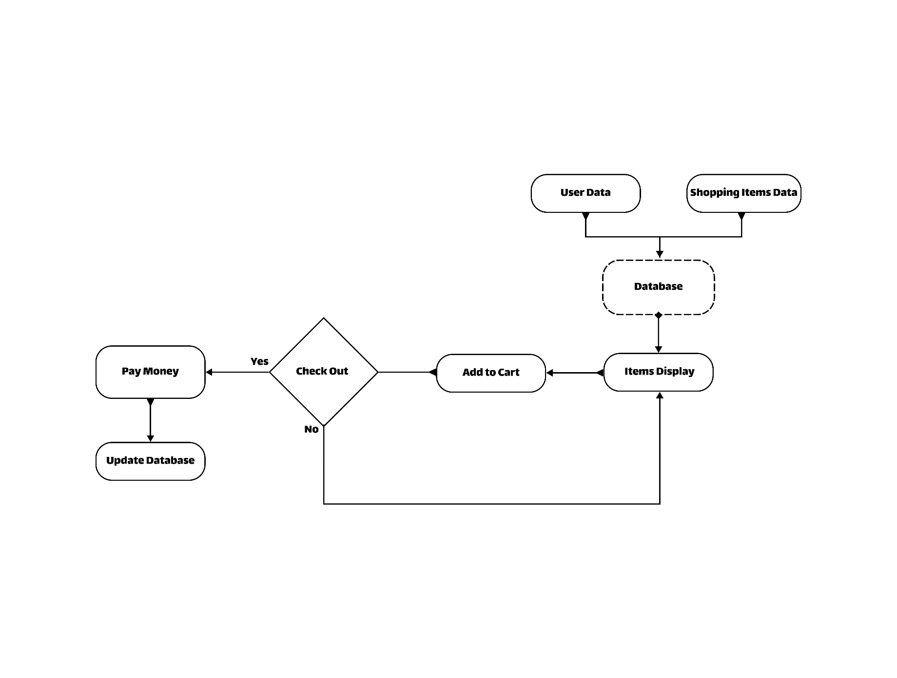

Figure 1: Context diagram of the Shopping Syste